





|  |  |
| --- | --- |
|  | Nanaparapu Surya Teja |
|  | 231DD01292 |
|  | CS&IT |
|  | 10-10-2025 |





Research Project submitted to VFSTR (Deemed-to-be University) In partial fulfillment of the requirements for the award of:



*Submittedby:*

*Nanaparapu Surya Teja*

USN: 231DD01292

*Undertheguidanceof:*

Mention your Guide’s Name

Praveen Kumar.K



Vadlamudi, Guntur-522 213

**2023-25**



I, Nanaparapu Surya Teja*,* hereby declare that the Research Project Report titled *“Fast food” has been* prepared by me under the guidance of the *.* I declare that this Project work is towards the partial fulfillment of the University Regulations for the award of the degree of Master of Computer Applications by VFSTR (Deemed-to-be University), Guntur. I have undergone a project for a period of Eight Weeks. I further

declare that this Project is based on the original study undertaken by me and has not been submitted for the award of any degree/diploma from any other University / Institution.

Place: Amujuru



This is to certify that the Research Project report submitted by Mr./Ms. Nanaparapu Surya Teja bearing 231DD01292 on the title *“FastFood”* is a record of project work done by him/ her during the academic year 2023-24 under my guidance and supervision in partial fulfillment of Master of Computer Applications.

Place: Amujuru



I extend my heartfelt gratitude to all those who have contributed to the successful completion of my project on 

First and foremost, I express my sincere appreciation to Prof Praveen kumar.k our esteemed guide, for her/his invaluable support, guidance, and encouragement throughout the course of this project. Her/his expertise, patience, and insightful feedback have been instrumental in shaping my project work.

I would also like to extend my gratitude to   , Director-CDOE VFSTR (Deemed to be University), for his continuous support and encouragement. His vision and leadership have provided us with a conducive environment for learning and exploration.

Furthermore, I acknowledge the contribution of , Additional Director- CDOE, VFSTR (Deemed to be University), for her assistance and support in various aspects of this project. Her guidance and encouragement has been deeply appreciated.

I am also thankful to all my colleagues and friends who provided us with their valuable insights, feedback, and encouragement throughout this journey.

Last but not the least, I would like to express my gratitude to my family members for their persistent support and understanding during this project.

[Nanaparapu Surya Teja]

[Master of computer application ] Batch :2023-2025

Place: Amujuru

Date:10-10- 2025

Nanaparapu Surya Teja

*USN:231DDO1292*



The fast-food industry stands as a hallmark of modern consumer culture, offering convenience, affordability, and familiarity to millions worldwide. This executive summary provides a succinct overview of the multifaceted landscape of fast food, encompassing its historical evolution, market dynamics, health implications, and cultural significance.

Historical Evolution:

Originating in the early 20th century with the emergence of diners and drive-ins, fast food underwent a trans formative evolution, propelled by innovations in food production, franchising, and marketing. Iconic brands such as McDonald's, KFC, and Burger King spearheaded this revolution, establishing standardized menus, streamlined operations, and global expansion strategies that would come to define the industry.

Market Dynamics:

The fast-food market continues to exhibit robust growth, fueled by changing consumer

preferences, urbanization, and globalization. With an estimated value surpassing trillions of

dollars annually, the industry commands a significant share of the global food market. Emerging economies, in particular, represent lucrative growth opportunities, as rising disposable incomes and urbanization drive demand for convenient dining options.

Health Implications:

Despite its widespread popularity, fast food has come under scrutiny for its adverse effects on public health. High in calories, sodium, and saturated fats, typical fast-food offerings contribute to the escalating rates of obesity, diabetes, and cardiovascular diseases worldwide. Public health campaigns and regulatory measures seek to address these concerns, advocating for greater transparency in nutritional labeling, menu diversification, and healthier ingredient options.

Cultural Significance:

Fast food transcends its culinary function to embody broader cultural and social phenomena. It serves as a symbol of modernization, globalization, and mass consumption, shaping dietary habits, lifestyle choices, and societal norms. The ubiquity of fast-food chains, along with their iconic branding and marketing campaigns, fosters a sense of familiarity and belonging across diverse cultural landscapes.



|  |  |
| --- | --- |
|  |  |
| Executive Summary | 3 |
| List of Tables | 5 |
| List of Graphs | 6 |
| Chapter 1: Introduction and Background | 7-9 |
| Chapter 2: Review of Literature | 10-12 |

|  |  |
| --- | --- |
| Chapter 3: Research Methodology | 13-18 |
| Chapter 4: Data Analysis and Interpretation | 19-30 |
| Chapter 5: Findings, Recommendations and Conclusion | 31-38 |
| References | - |
| Annexures | - |

|  |  |  |
| --- | --- | --- |
|  |  |  |
| 1 | Bar graphs | 21-32 |
| 2 | Pie charts | 21-32 |





The purpose of conducting a study on fast foods is to gain comprehensive insights into various aspects of this prevalent food category, spanning from its nutritional composition to its broader societal, economic, and health implications. By delving into the nutritional content of fast foods, researchers aim to understand their impact on public health, particularly concerning issues such as obesity, cardiovascular diseases, and other diet- related conditions. Additionally, such studies seek to uncover patterns of fast food consumption among different demographic groups, shedding light on disparities and potential health risks. Beyond health concerns, the societal and cultural influences of fast foods are also examined, elucidating their role in shaping dietary habits, lifestyles, and community food environments. Furthermore, researchers investigate the economic dynamics of the fast food industry, including its market trends, employment patterns, and contributions to the overall economy. Ultimately, the purpose of studying fast foods is multifaceted, aiming to inform policy decisions, public health strategies, and consumer behavior interventions to promote healthier dietary choices and mitigate the adverse effects associated with excessive fast food consumption.



Fast food is a type of mass-produced food designed for commercial resale and with strongly placed on “speed of service” versus other relevant factors involved in culinary science .Fast food was originally created as a commercial strategy to accommodate the larger numbers of busy commuters,travelers and wage workers who often did not have the time to sit down at public house or diner and wait for their meal. By making speed of service the priority,this ensured that customers with strictly limited time(a commuter stopping to procure dinner to bring home to their family, for example,or an hourly laborer on a short lunch break)were not inconvenienced by waiting for their food to be cooked on the spot.For those with no time to spare,fast food became a multi billion-dollar industry.

Fast food, a hallmark of contemporary dining, has become an integral part of modern society's culinary landscape. Defined by its quick service, convenience, and often standardized menu offerings, the fast-food industry has experienced exponential growth and global proliferation over the past century. Originating in the early 20th century with the emergence of diners and drive-ins, fast food has evolved into a multi-billion-dollar industry, dominated by iconic brands such as McDonald's, Burger King, and KFC.



Fast food, a hallmark of contemporary dining, has become an integral part of modern society's culinary landscape. Defined by its quick service, convenience, and often standardized menu offerings, the fast-food industry has experienced exponential growth and global proliferation over the past century. Originating in the early 20th century with the emergence of diners and drive-ins, fast food has evolved into a multi-billion-dollar industry, dominated by iconic brands such as McDonald's, Burger King, and KFC.



The study of fast foods encompasses various theoretical concepts from multiple disciplines, shedding light on its intricate dynamics and implications. One prominent theoretical framework is drawn from public health, where scholars analyze fast-food consumption through the lens of nutrition, epidemiology, and health behavior theories. Concepts such as the nutritional transition, food environment, and social determinants of health provide valuable insights into the factors influencing individuals' dietary choices and the consequent impact on public health outcomes. Additionally, sociological theories, including structural functionalism and symbolic interaction-ism, offer perspectives on fast food's role in shaping social structures, cultural norms, and identity construction. These theories explore how fast food becomes embedded within broader social systems and influences patterns of consumption, social interactions, and cultural practices. Moreover, economic theories such as consumer behavior, demand and supply dynamics, and market competition elucidate the industry's growth, market segmentation, and pricing strategies. By integrating these theoretical concepts, researchers can develop a comprehensive understanding of fast foods, spanning from individual behaviors to broader societal trends, thereby informing strategies for promoting healthier, more sustainable food systems.



The fast-food industry represents a cornerstone of the global food service sector, characterized by its emphasis on speed, convenience, and mass production. With origins tracing back to the early 20th century, the industry has experienced rapid growth and expansion, becoming a ubiquitous presence in urban centers and suburban landscapes

worldwide. Iconic brands such as McDonald's, Burger King, and KFC dominate the market, employing standardized menus, streamlined operations, and aggressive marketing strategies to attract customers. The industry's success is fueled by changing consumer lifestyles, urbanization, and globalization, which have led to increased demand for quick and affordable dining options. Despite its popularity, the fast-food industry faces scrutiny over its nutritional content, environmental impact, and labor practices. Public health concerns regarding the high levels of calories, sodium, and unhealthy fats in fast-food offerings have prompted calls for greater regulation and consumer education. Additionally, environmental advocates highlight the industry's contribution to issues such as packaging waste and deforestation, urging companies to adopt more sustainable practices. Nevertheless, the fast-food industry continues to thrive, adapting to evolving consumer preferences and market trends while remaining a dominant force in the global food service landscape.

1





A specific review on fast foods typically aims to comprehensively analyze various aspects of this food category, ranging from their nutritional profiles to their societal impacts. These reviews often delve into the composition of fast foods, examining their levels of calories, fats, sugars, sodium, and other nutrients or additives. Additionally, they may scrutinize the portion sizes and serving practices prevalent in fast food establishments.

Beyond nutritional content, such reviews also explore the health implications associated with regular fast food consumption. This can include investigating links to obesity, cardiovascular diseases, diabetes, and other health conditions. Furthermore, researchers may assess the prevalence of fast food consumption among different demographic groups and its correlation with various health outcomes.

In terms of societal impact, reviews on fast foods may explore their influence on cultural norms, dietary habits, and food environments. They may analyze advertising strategies employed by fast food companies, their impact on consumer behavior, and the role of fast food establishments in shaping community food landscapes.

Economically, reviews may examine the growth and profitability of the fast food industry, employment patterns within it, and its broader economic contributions. They may also assess policy interventions aimed at regulating fast food marketing, improving nutritional standards, or promoting healthier alternatives.

Ultimately, a specific review on fast foods provides a comprehensive understanding of the multifaceted implications of this ubiquitous food category, informing policy decisions, public health strategies, and consumer choices.



A gap analysis on fast foods involves identifying discrepancies or deficiencies in existing research, policies, or practices related to this food category. Here's how such an analysis might be structured:

1. : Identify gaps in knowledge

regarding the nutritional content of fast foods and their specific health impacts. This could involve assessing which nutrients or additives are often overlooked

in existing studies, such as trans fats or preservatives, and their potential health consequences. Additionally, explore gaps in understanding how different fast food items or consumption patterns affect various health outcomes across different demographic groups.



2. : Analyze gaps in research on the societal and cultural influences of fast foods. This may include investigating how cultural norms and preferences shape the availability and consumption of fast foods in different regions or communities. Identify areas where more research is needed to understand the sociocultural factors driving fast food consumption and its implications for public health and well-being.

3. : Assess gaps in knowledge regarding the environmental impact of fast food production, distribution, and consumption. This could involve exploring the carbon footprint of popular fast food items, the sustainability of sourcing practices, and the waste generated by packaging and food preparation. Identify areas where more research is needed to understand and mitigate the environmental consequences of the fast food industry.

4. : Evaluate gaps in policies and regulations aimed at addressing the health, social, and environmental challenges associated with fast foods. Identify areas where existing policies may be insufficient or ineffective, such as in regulating marketing practices targeting children or enforcing nutritional labeling requirements. Additionally, assess gaps in the implementation and enforcement of existing regulations and identify potential barriers to effective policy interventions.

5. : Explore gaps in understanding

consumer behavior and decision-making processes related to fast food consumption. This could involve investigating factors influencing food choices, such as price, convenience, taste, and social influences. Identify areas where more research is needed to develop effective strategies for promoting healthier eating habits and reducing reliance on fast foods.

By conducting a thorough gap analysis on fast foods across these dimensions, researchers, policymakers, and stakeholders can identify priority areas for further research, policy development, and intervention to address the complex challenges associated with this food category.





3



3.1

Objective of the project includes

To compare the trends of fast food consumption according to Age,Gender.

 To find out which is the most preferred fast food among people.

To analyse the main reason for choosing the fast food to eat.



 TO analyse whether parents will prefer fast food to children or not.

 To analyse fast food is providing more quality or not.



The scope of a study on fast foods encompasses a broad array of interconnected factors that influence and are influenced by the consumption of these food items. At its core, such a study aims to comprehensively examine various dimensions, including but not limited to, nutritional content, health impacts, societal implications, economic aspects, and consumer behaviors.

Firstly, the study may focus on analyzing the nutritional composition of fast foods, assessing their levels of calories, fats, sugars, sodium, and other nutrients or additives. This involves understanding how different types of fast foods contribute to overall dietary intake and potential health outcomes.

Secondly, the study may delve into the health implications associated with regular fast food consumption, including its correlation with obesity, cardiovascular diseases, diabetes, and other health conditions. This aspect often involves examining

epidemiological data, clinical studies, and meta-analyses to determine the extent of the health risks posed by fast foods.



Thirdly, the societal scope of the study involves exploring the cultural, social, and environmental influences of fast foods. This includes analyzing how fast food consumption patterns vary across different demographic groups, cultural contexts, and geographic regions. Additionally, the study may investigate the impact of fast food marketing, advertising, and accessibility on consumer choices and community health.

Fourthly, from an economic standpoint, the study may assess the growth, profitability, and market dynamics of the fast food industry. This involves examining factors such as market trends, industry competition, employment patterns, and the economic contributions of fast food establishments to local and national economies.

Finally, the study may explore consumer behaviors and attitudes towards fast foods, including factors influencing food choices, preferences, and decision-making processes. This aspect often involves survey research, focus groups, and consumer behavior analysis to understand the drivers of fast food consumption and inform interventions aimed at promoting healthier dietary habits.

Data is the main important source of the project and the aim of this activity ,is to provide sufficient data based on society. This is achieved by means of improvement of knowledge and practical skills regarding to this study and it conducts short-term surveys on impact of fast-foods on society.The data pertaining to the study is both primary and secondary data.

Designing a research study on fast foods requires careful consideration of various methodological aspects to ensure robustness and validity of findings. Here's an outline of a research design for studying fast foods:

Clearly define the objectives of the study, which may include investigating the nutritional content, health impacts, societal

influences, economic aspects, or consumer behaviors related to fast foods. Develop specific hypotheses or research questions to guide the investigation.



Determine the target population for the study, which could include individuals of different ages, genders, socioeconomic backgrounds, and geographic locations. Employ appropriate sampling techniques to select a representative sample from the population,ensuring diversity and generalization of findings.

Choose suitable data collection methods based on the research objectives and hypotheses. This may involve a combination of quantitative and qualitative approaches, such as surveys, interviews, dietary assessments, focus groups, or observational studies. Consider using validated tools and instruments for measuring dietary intake, health outcomes, and other relevant variables.

Define the key variables to be measured in the study, including nutritional parameters (e.g., calories, macro nutrients, micro nutrients), health indicators (e.g., body mass index, blood pressure, cholesterol levels), sociolect - demographic characteristics, economic factors, and consumer behaviors. Use standardized protocols and techniques to ensure consistency and reliability of measurements.

If conducting experimental research, design appropriate interventions or treatments to manipulate variables of interest (e.g.,

types of fast foods, portion sizes, frequency of consumption). Implement control

measures to minimize bias and confounding factors, such as randomization, blinding, and placebo controls.

Specify the statistical or analytical methods to be used for data analysis, based on the research questions and types of data collected. This may include descriptive statistics, inferential tests (e.g., t-tests, chi-square tests, regression analysis), or qualitative thematic analysis. Consider potential excoriates or moderators to be included in the analysis to enhance the validity of results.

Address ethical considerations related to participant recruitment, informed consent, privacy, confidentiality, and potential risks associated with the study. Obtain approval from relevant institutional review boards or ethics committees before initiating data collection.

Interpret the findings in light of the research objectives and hypotheses, discussing their implications for theory, practice, and

policy. Clearly communicate the results through appropriate formats, such as research articles, reports, presentations, or policy briefs, targeting relevant stakeholders and audiences.



 It is the important and data that was directly collected from the sources such as personal interviews,questionnaires or surveys on technology. This primary data information is collected by interacting with the various people on the society.The sample size of the questionnaires is 200. That means the information is collected from 200 people on society.

 The secondary data for the study was gathered from books,journals,articles and websites



* Simple random sampling is the sampling method applied for the research. With the simple random sampling technique,a random portion of the total population chosen to represent the complete population.





* 



The study was carried out in the kakinada city.

The period of study refers to the specific duration or time frame during which a research study is conducted.It indicates the temporal scope of the search and defines the boundaries within which data is collected, analyzed and interpreted .The period of study is a crucial aspect of research design as it helps contextualize the findings

and allow meaningful comparisons. For Example, if a study aims to analyze the fast foods the period of study could be defined as “from december2022 to February 2023” this means that data related to fast foods will be collected and analyzed within the specific 12 months time frame. Its important to carefully select the period of study to align with the research objectives and ensure that the data collected is relevant and reflective of the intended scope.



* As the time span was limited three months all the sample consumers could not be covered in the course of the study.
* The area selected was both urban and rural areas.
* Difficulties in collection of accurate data as there is possibility of biased answers from the respondents.
* The size of the sample has been restricted to 250 .Hence the small sample makes it difficult to apply it to the universal group.

1. : Many fast food options are high in calories, saturated fats, sugars, and sodium while lacking essential nutrients like fiber, vitamins, and minerals. Regular consumption of such foods can contribute to poor dietary quality and increase the risk of obesity, cardiovascular diseases, diabetes, and other diet- related health conditions.



1. : Fast food consumption has been linked to weight gain and obesity due to its high energy density, large portion sizes, and frequent consumption of sugary drinks and high-calorie items. Obesity is a significant public health concern associated with various health complications and reduced quality of life.



1. : Fast food consumption is often associated with poorer dietary habits, including lower intake of fruits, vegetables, whole grains, and other nutritious foods. This can lead to deficiencies in essential nutrients and contribute to overall poor health outcomes.
2. : Regular consumption of fast food has been linked to an increased risk of chronic diseases such as type 2 diabetes, hypertension, epidemically, and certain types of cancer. The excessive intake of unhealthy fats,

sugars, and sodium in fast food can negatively impact metabolic health and increase the likelihood of developing these conditions.



1. : The production, distribution, and disposal of fast food products can have significant environmental consequences, including deforestation, greenhouse gas emissions, water pollution, and waste generation. The industrialized production methods and packaging materials used in the fast food industry contribute to environmental degradation and climate change.



1. : Fast food consumption is often more prevalent among socioeconomically disadvantaged populations due to factors such as lower cost, greater accessibility, and limited access to healthier food options. This can exacerbate existing social and economic disparities in health outcomes and contribute to inequalities in disease burden.



1. : The fast food industry invests heavily in



marketing and advertising campaigns targeting children, adolescents, and vulnerable populations. These promotions often emphasize convenience, taste, and affordability while downplaying the health risks associated with frequent fast food consumption, leading to increased demand and consumption.

1. : Some fast food items are engineered to be highly palatable and addictive, leading to cravings and over consumption. The combination of high levels of salt, sugar, fat, and flavor enhancers can stimulate the brain's reward centers, contributing to addictive eating behaviors and difficulties in controlling food intake.

Research on fast foods serves a vital role in informing public health policies, guiding consumer choices, and promoting healthier dietary habits. By investigating various aspects of fast food consumption, such as its nutritional content, health impacts, societal influences, economic implications, and consumer behaviors, research provides valuable insights into the complex relationship between fast food and human health. This research helps to identify the nutritional deficiencies and health risks associated with regular fast food consumption, such as obesity, cardiovascular diseases, and diabetes, thereby raising awareness among policymakers, healthcare professionals, and the general public. Furthermore, studies on fast foods shed light on the societal and cultural influences driving fast food consumption, informing interventions aimed at promoting healthier eating habits and addressing disparities in access to nutritious foods. Additionally, research on the economic dynamics of

the fast food industry informs policy decisions regarding food regulation, taxation, and marketing practices, with implications for public health and social welfare. Overall, research on fast foods plays a crucial role in advancing our understanding of the multifaceted implications of this food category and in shaping evidence-based strategies for improving public health and well-being.





Data analysis and interpretation in studies on fast foods involve rigorous examination of collected data to uncover patterns, trends, and associations related to fast food consumption and its impacts. Researchers employ various statistical and analytical techniques to derive meaningful insights from the data, which inform conclusions and recommendations.

Firstly, researchers conduct descriptive analyses to summarize key characteristics of fast food consumption, such as frequency, types of foods consumed, and nutritional content. This includes calculating measures such as means, standard deviations, frequencies, and percentages to describe the distribution of variables within the datasets.



Secondly, inferential analyses are performed to test hypotheses and determine relationships between fast food consumption and health outcomes, demo-graphical factors, or other variables of interest. This may involve conducting correlation analyses, t-tests, chi-square tests, regression analyses, or multivariate analyses to assess associations and identify predictors of fast food consumption and related outcomes.

Furthermore, subgroup analyses may be conducted to examine differences in fast food consumption patterns across demographic groups (e.g., age, gender, income, education) or geographic regions. This helps to identify disparities and tailor interventions to specific populations.

|  |  |  |
| --- | --- | --- |
|  |  |  |
|  |  |  |
|  |  |  |
|  |  |  |
|  |  |  |

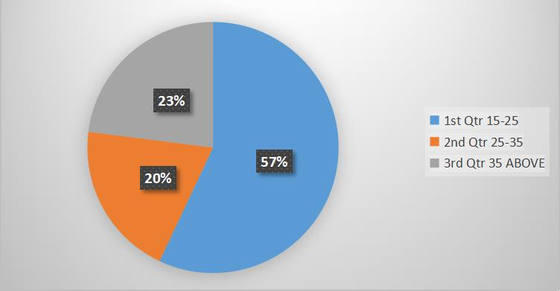

1. GENDER
   1. Male B)Female

|  |  |  |  |
| --- | --- | --- | --- |
| OPTIONS | NO OF PARTICIPANTS | PERCENTAGE | |
| MALE | 111 | 44% | |
| FEMALE | 139 | 56% | |
| TOTAL | 250 | 100% | |
| Fried chicken noodles Manchuria Panipuri | | |  |

1. Qualification

a)10th b)Inter c)Degree d)pg e)B-Tech f)Others

|  |  |  |
| --- | --- | --- |
| Options | No of participants | Percentage |
| 10 | 31 | 12% |
| Inter | 19 | 8% |

|  |  |  |
| --- | --- | --- |
| Degree | 74 | 30% |
| Pg | 54 | 22% |
| B-Tech | 31 | 12% |
| others | 41 | 16% |
| TOTAL | 250 | 100% |

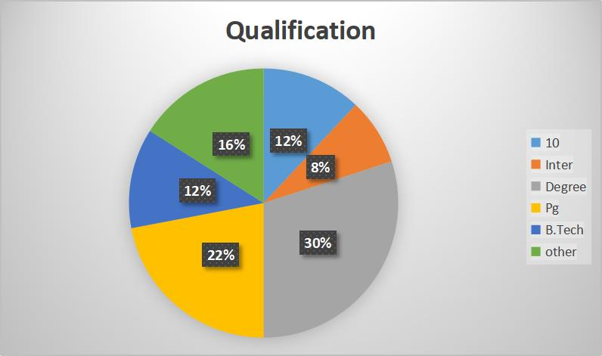

1. Employee:
   1. Govt B)Private C)Business D)others

|  |  |  |
| --- | --- | --- |
| Options | No of participants | percentage |
| Govt | 19 | 8% |
| Private | 52 | 21% |
| Business | 16 | 6% |

|  |  |  |
| --- | --- | --- |
| Others | 163 | 65% |

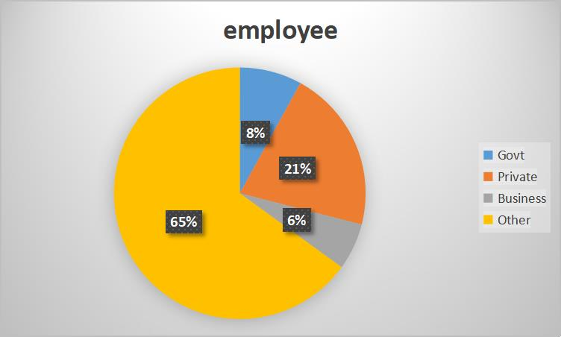

1. Area
   1. Rural B)Urban

|  |  |  |
| --- | --- | --- |
| options | No of participants | percentage |
| Rural | 111 | 44% |
| Urban | 139 | 56% |

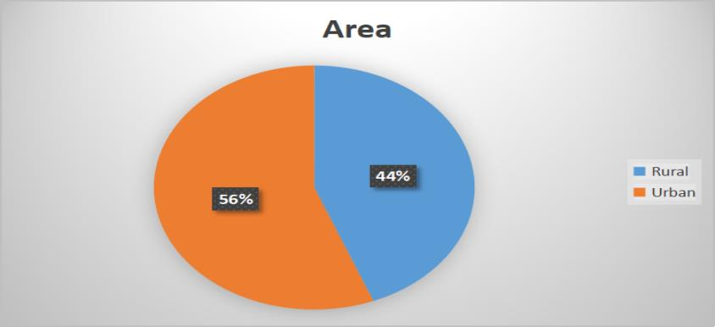

1. What is the main reason for choosing fast food to eat?
   1. Taste B)price C)Limited time for cooking D)variety of options

|  |  |  |
| --- | --- | --- |
| options | No of participants | percentage |
| Taste | 134 | 54% |
| Price | 9 | 3% |
| Limited time for  cooking | 43 | 17% |
| Variety of options | 64 | 26% |

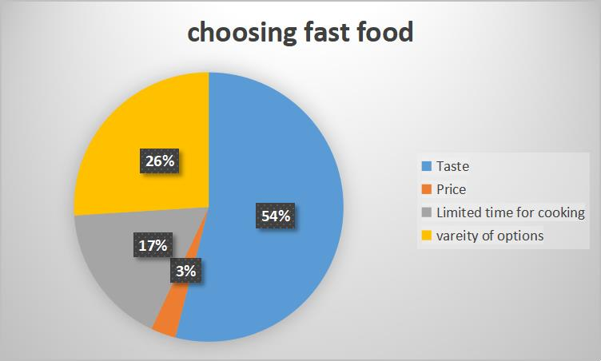

1. Do you think fast food providing more quality?
   1. yes B)No

|  |  |  |
| --- | --- | --- |
| Options | No of participants | percentage |
| Yes | 49 | 20% |
| No | 201 | 80% |

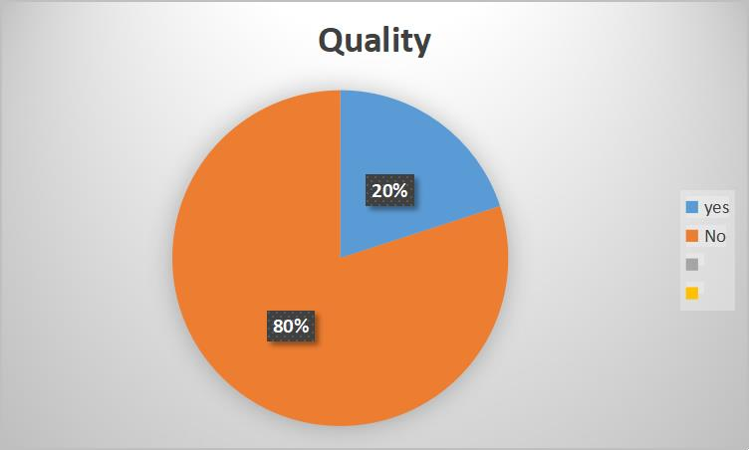

1. Will they parents will prefer fast food to children or not?
   1. Yes B)No

|  |  |  |
| --- | --- | --- |
| options | No of participants | percentage |
| Yes | 55 | 22% |
| No | 195 | 78% |

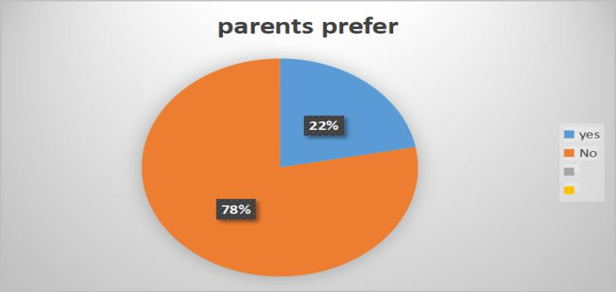

1. How many times a week do you eat fast food?
   1. Every Day B)once a week C)Once a month

|  |  |  |
| --- | --- | --- |
| Options | No of participants | percentage |

|  |  |  |
| --- | --- | --- |
| Every day | 40 | 16% |
| week | 109 | 44% |
| month | 101 | 40% |

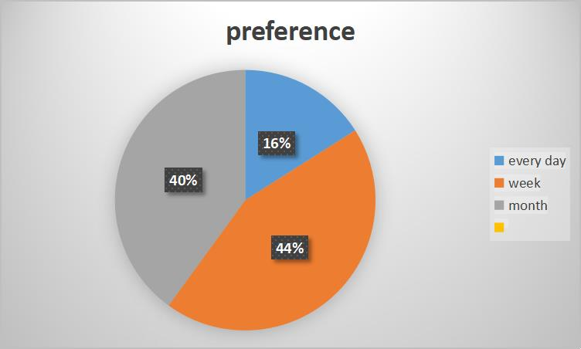

1. Do you think fast food is a convenient and cheap alternative to homemade foods?
   1. Yes B)No

|  |  |  |
| --- | --- | --- |
| Options | No of participants | percentage |
| Yes | 131 | 52% |
| No | 119 | 48% |

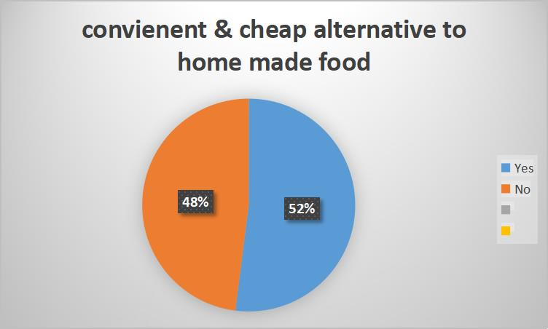

1. Fast food is healthy or not?
   1. Yes B)No

|  |  |  |
| --- | --- | --- |
| Options | No of participants | percentage |
| Yes | 26 | 10% |
| No | 224 | 90% |

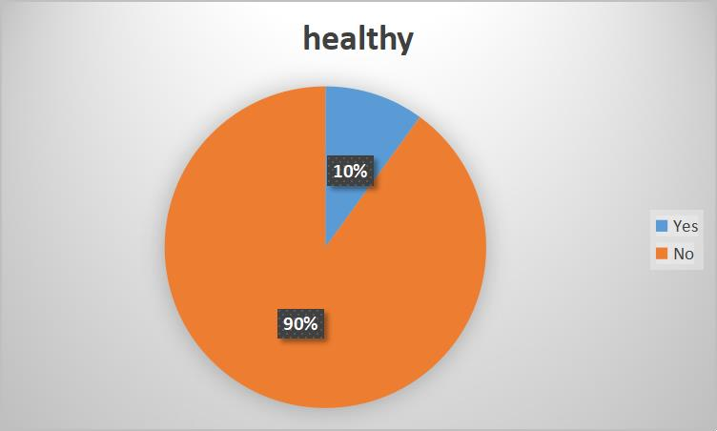

1. What are the situations to choose fast food?
   1. Busy schedule B)Less price C)Taste

|  |  |  |
| --- | --- | --- |
| Options | No of participants | percentage |
| Busy schedule | 90 | 36% |
| Less price | 30 | 12% |
| Taste | 130 | 52% |

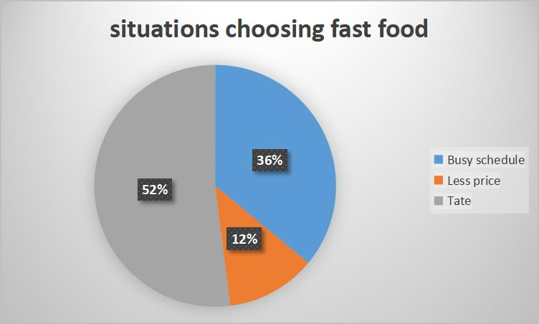

1. Which food do you prefer mostly?
   1. Fast food B)Homemade food

|  |  |  |
| --- | --- | --- |
| options | No of participants | percentage |
| Fast food | 58 | 23% |
| Homemade food | 172 | 77% |

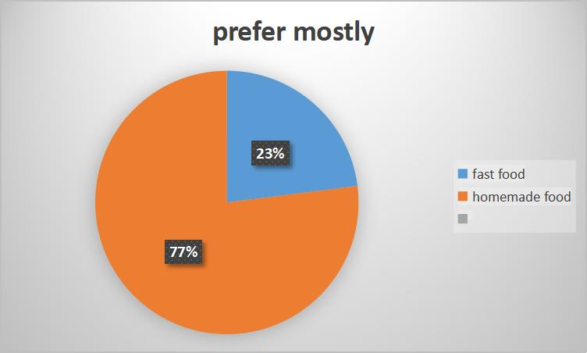

1. Whether urban people can live without fast foods?
   1. Yes B)No

|  |  |  |
| --- | --- | --- |
| options | No of participants | percentage |
| Yes | 101 | 40% |

|  |  |  |
| --- | --- | --- |
| No | 149 | 60% |

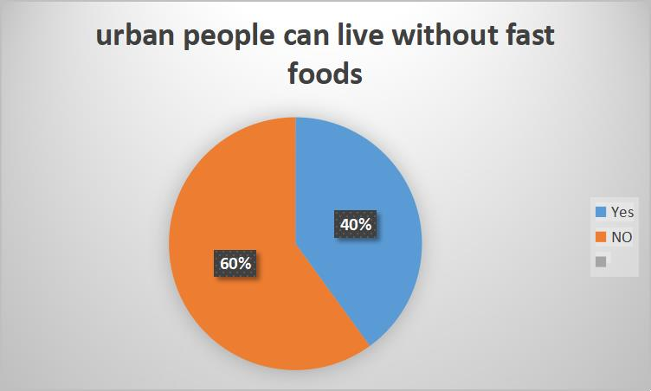

1. Do you think the environment would be positively affected if more people decided to sustain fast foods?
   1. Yes B) NO

|  |  |  |
| --- | --- | --- |
| Options | No of participants | percentage |
| Yes | 105 | 42% |
| NO | 145 | 58% |

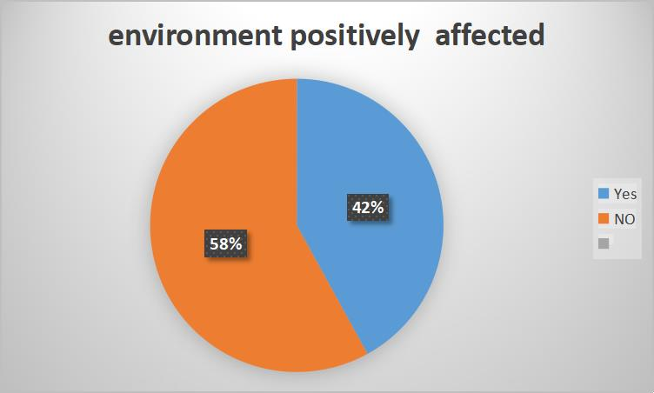

1. What food do you usually order at a fast food centre?
   1. Fried chicken B)Noodles C)Manchuria D)Panipuri

|  |  |  |
| --- | --- | --- |
| Options | No of participants | percentage |
| Fried chicken | 74 | 29% |
| Noodles | 64 | 26% |
| Manchuria | 49 | 20% |
| Panipuri | 63 | 25% |

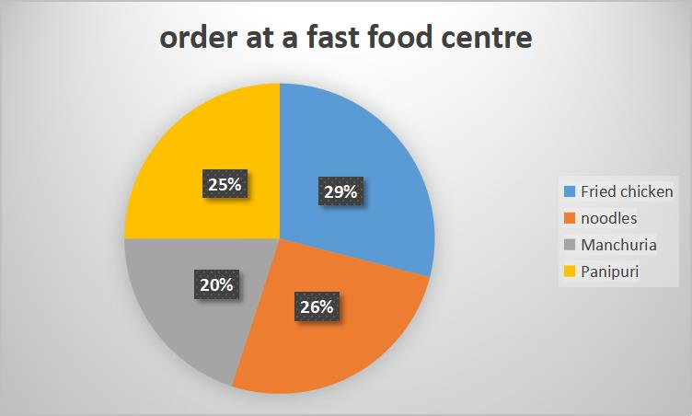









* From the AGE pie chart shows the most people involved in the age 15- 25 is 57%,age of 35 and above is 23% and age of 25-35 is 20%
* From the GENDER pie chart shows the most female people is 56% and male involved is 44%
* From the Qualification pie chart shows the most of the degree qualification is 30%,pg is 22%,other is 16% , 1oth and B-tech is 12%and inter is 8%
* From the EMPLOYEE pie chart shows the most of the other employees is 65%, private is 21% ,govt is 18% and business is 6%
* From the AREA pie chart shows the most of the people prefer fast foods from urban area is 56% comparative tom the rural area is 44%
* From the MAIN REASON CHOOSING FAS T FOOD pie chart shows first prefer is taste 54% next variety of options is 26% next limited time for cooking is 17% and very less people prefer fast food for low price is 3%
* From the QUALITY pie chart shows the most people think fast food is not providing more quality is 80% and less people think fast food is providing more quality is 20%
* From the PARENTS WILL PREFER FAST FOOD FOR CHILDREN

pie chart shows the most parents will not prefer fast food for children is 78% and very few parents will prefer fast food for children is 22%

* From WEEK pie chart shows that the most of the people eat fast food once a week is 44% some of the people eat fast food once a month is 40% and very few people east fast food every day is 16%
* *FromCONVENIENTANDCHEAPALTERNATIVETO*

*HOMEMADEFOODSpiechartshowsthatthemostofthepeoplethink fastfoodisaconvenientandcheapalternativetohomemadefoodsis 52%fewpeoplethink fastfoodisnot aconvenientandcheapalternative tohomemadefoodsis48%*

* *FromHEALTHY piechartshowsthatthemostofthepeoplesaysfast foodisnothealthyis90%andfewpeoplesayfastfoodishealthyis10%.*
* *FromSITUATIONSTOCHOOSEFASTFOODpiechartshowsthethemain reasonforchoosingfastfood toeatistasteis52%.Inbusyschedule peoplewi****l****preferfastfoodtoeatis36%andfewpeoplewi****l****preferfast foodforlesspriceis12%*
* *FromPREFERMOSTLYpie showsthatthepeopleprefermosthome made foodis77%andfewpeoplewi****l****preferfastfoodis23%*
* *FromURBANPEOPLECANLIVEWITHOUNTFASTFOODpie*

*chartshowsthattheurbanpeoplecannotlivewithoutfastfoodis60% andfewpeoplecanlivewithoutfastfoodis40%*

* *FromENVIRONMENTWOULDBEPOSITIVELY AFFECTEDpie*

*chartshowsthatpeoplethinktheenvironmentwouldbepositivelynot affectedtosustainfastfoodis58%andfewpeoplethinktheenvironment wouldbepositivelyaffectedtosustainfastfoodis42%*

* *From Orderatthefastfoodcenterpiechartshowsthatthemostofthe peopleorderatfastfoodcenterisfriedchickenis29%somepeople eatNoodlesis25%andveryfewpeopleeatManchuriaandpanipuries is20-25%.*

**



Research on fast food has yielded several general findings regarding its impact on health, society, and the economy. Firstly, studies consistently highlight the nutritional deficiencies associated with fast food consumption,

which often includes high levels of calories, saturated fats, sugars, and sodium, along with low amounts of essential nutrients such as fiber, vitamins, and minerals. These nutritional shortcomings contribute to adverse health outcomes, with regular fast food consumption linked to obesity, cardiovascular diseases, type 2 diabetes, and other chronic conditions. Furthermore, research underscores the societal influences driving fast food consumption, including cultural norms, marketing strategies, and socioeconomic factors, which contribute to disparities in access to healthy foods and health outcomes. Economically, the fast food industry plays a significant role in employment and revenue generation but also raises concerns about labor practices, environmental sustainability, and public health costs associated with diet-related diseases. Overall, the general findings on fast food underscore the need for comprehensive strategies to address its negative health impacts, promote healthier dietary habits, and create environments supportive of nutritious food choices.



|  |  |  |  |  |  |  |
| --- | --- | --- | --- | --- | --- | --- |
| Improving fast foods requires a multi-faceted approach that addresses various aspects of production, marketing, accessibility, and consumer behavior. Here are several suggestions for areas of improvement: | | | | | | |
| Nutritional Reformulation | | : Encourage fast food companies to reformulate their | | | | |
| products to reduce levels of unhealthy nutrients such as saturated fats, sugars, and sodium, while increasing the content of beneficial nutrients like fiber, vitamins, and minerals. This can be achieved through innovative ingredient substitutions, portion size adjustments, and cooking techniques that prioritize health without  compromising taste. | | | | | | |
| Menu Diversification | : Expand the variety of healthier options on fast food menus, | | | | | |
| including more plant-based and whole food choices such as salads, grilled vegetables, lean proteins, and whole grain options. Increasing the availability of nutritious alternatives can provide consumers with more options to make healthier  choices while dining out. | | | | | | |
| Transparent Nutrition | Labeling | | : Implement | clear | and | easy-to-understand |
| nutrition labeling on fast food menus and packaging, including information on calorie counts, nutrient content, and recommended serving sizes. This empowers consumers to make informed decisions about their food choices and encourages restaurants to offer healthier options. | | | | | | |

: Improve the nutritional quality of children's meals

Promotion of Children's Meals

|  |  |  |  |  |
| --- | --- | --- | --- | --- |
| offered by fast food chains by reducing the calorie, fat, sugar, and sodium content and including healthier side options such as fruits, vegetables, and low-fat dairy products.  Additionally, limit marketing of unhealthy foods to children to promote healthier eating habits from a young age. | | | | |
| Healthier Cooking Methods | | | : Encourage fast food establishments to adopt healthier | |
| cooking methods such as grilling, baking, and steaming instead of frying, which reduces the amount of unhealthy fats and calories in prepared foods. This can improve the overall nutritional quality of fast food offerings without compromising  taste or texture. | | | | |
| Community Partnerships | | : Foster partnerships between fast food chains and | | |
| community organizations, schools, and healthcare providers to promote health education, cooking skills, and nutrition literacy among consumers. These partnerships can support initiatives such as cooking classes, nutrition workshops,  and community gardens to encourage healthier eating habits. | | | | |
| Environmental Sustainability | | | | : Promote sustainable practices within the fast food |
| industry, including sourcing ingredients from local and sustainable suppliers, reducing food waste through composting and recycling programs, and minimizing  the use of single-use plastics and packaging materials. This helps to mitigate the environmental impact of fast food production and distribution. | | | | |
| Government  Regulations | : Advocate for government regulations and policies that | | | |
| promote healthier food environments, such as menu labeling laws, restrictions on marketing unhealthy foods to children, and taxes or subsidies to incentive healthier food choices. Government intervention can help create a level playing field and encourage industry-wide improvements in fast food offerings.  By focusing on these areas of improvement, stakeholders can work towards making fast foods healthier, more sustainable, and more conducive to overall well-being, while still maintaining convenience and affordability for consumers. | | | | |



Future research on fast foods holds significant potential for advancing our understanding of their complex impacts on health, society, and the economy, and for informing evidence-based interventions to promote healthier dietary habits. One area for exploration is the development and evaluation of innovative strategies for improving the nutritional quality of fast food offerings, such as reformulation of ingredients, menu diversification, and cooking methods. Additionally, there is a need for longitudinal studies to assess the long-term health outcomes associated with different patterns of fast food consumption, including the role of genetic and

environmental factors in mediating these effects. Research exploring the socio- cultural influences driving fast food consumption, as well as disparities in access to healthy foods across diverse populations, can provide insights into effective policy interventions to address these inequalities. Furthermore, there is scope for investigating the economic implications of fast food consumption, including its impact on healthcare costs, productivity, and labor markets, as well as the potential economic benefits of promoting healthier food environments. Finally, research on the environmental sustainability of fast food production and distribution, including the carbon footprint, waste generation, and resource usage, can inform efforts to mitigate the environmental impact of the fast food industry. By addressing these research gaps, future studies on fast foods have the potential to contribute to the development of comprehensive strategies for promoting public health, reducing health inequities, and fostering sustainable food systems.



* Out of various reasons for the consumption of fast food like taste ,variety of options and time savings. Taste is the most preferred reason among the students to eat fast food.
* From various fast food listed in our schedules like fried chicken, Noodles,Manchuria and pani puries. The most preferred fried chicken.
* Out of 250 participates 90% said that eating fast food is unhealthy also rest of the people are aware about the health risks and also faced many problems and facts. Students are still eating fast food and this bar is keeping on increasing.
* As we have discussed earlier that fast food have some advantages like time saving, easy accessible etc. And some disadvantages like it creates health problem and is responsible for the decrease amount of socialization.